

Name:Rubini Raju
Login Id:rubini@oasis-portal.com
Course Title:Accounting Fundamentals
Subject Code:BHM03

Submitted date:14/08/2017

TABLE OF CONTENTS

NO | DETAILS | PAGE
1 | EXECUTIVE SUMMARY | 2
2 | INTRODUCTION | 3-4
3 | ASSIGNMENT QUESTION
 | PART 1 | 5-6
 | PART 2 | 7-8
 | PART 3 | 9-10
 | PART 4 | 11-12
8 | CONCLUSION | 13
9 | REFERENCES | 14
10 | APPENDIX | 15

1

Executive Summary

In the module, I covered the topic about Accounting Fundamentals within a Hospitality Management. In starting part, we can see the introduction of Accounting Fundamentals. What is Accounting Fundamentals and how importance our Accounting Fundamentals in hotel industry? In first part,I studied the comprehensive response and the role of accounting and will explain the comprehensive response in Accounting Fundamentals. In the second part, I will describe difference between accounts payable and accounts receivable. Third part, I have understood how a company’s profit appear as a credit on it’s balance sheet. Finally, I will explain topic on meant. By reconciling an account.

2
Introduction

This explanation of accounting basics will introduce you to some basic accounting principles, accounting concepts, and accounting terminology. Once you become familiar with some of these terms and concepts, you will feel comfortable navigating through the explanations, quizzes, puzzles, and other features of AccountingCoach.com.
Some of the basic accounting terms that you will learn include revenues, expenses, assets, liabilities, income statement, balance sheet, and statement of cash flows. You will become familiar with accounting debits and credits as we show you how to record transactions. You will also see why two basic accounting principles, the revenue recognition principle and the matching principle, assure that a company's income statement reports a company's profitability.
In this explanation of accounting basics, and throughout all of the free materials and the PRO materials—we will often omit some accounting details and complexities in order to present clear and concise explanations. This means that you should always seek professional advice for your specific circumstances.
Note: We provide visual tutorials, flashcards, exam questions, videos, and forms for members of AccountingCoach PRO.
A Story for Relating to Accounting Basics
We will present the basics of accounting through a story of a person starting a new business. The person is Joe Perez—a savvy man who sees the need for a parcel delivery service in his community. Joe has researched his idea and has prepared a business plan that documents the viability of his new business.
Joe has also met with an attorney to discuss the form of business he should use. Given his specific situation, they concluded that a corporation will be best. Joe decides that the name for his corporation will be Direct Delivery, Inc. The attorney also advises Joe on the various permits and government identification numbers that will be needed for the new corporation.
Joe is a hard worker and a smart man, but admits he is not comfortable with matters of accounting. He assumes he will use some accounting software, but wants to meet with a professional accountant before making his selection. He asks his banker to recommend a professional accountant who is also skilled in explaining accounting to someone without an accounting background. Joe wants to understand the financial statements and wants to keep on top of his new business. His banker recommends Marilyn, an accountant who has helped many of the bank's small business customers.
3

Note: To learn about the roles of accountants and CPAs visit our free Accounting Career Center.
At his first meeting with Marilyn, Joe asks her for an overview of accounting, financial
statements, and the need for accounting software. Based on Joe's business plan, Marilyn sees that there will likely be thousands of transactions each year. She states that accounting software will allow for the electronic recording, storing, and retrieval of those many transactions. Accounting software will permit Joe to generate the financial statements and other reports that he will need for running his business.
Joe seems puzzled by the term transaction, so Marilyn gives him five examples of transactions that Direct Delivery, Inc. will need to record:
Joe will no doubt start his business by putting some of his own personal money into it. In effect, he is buying shares of Direct Delivery's common stock.
Direct Delivery will need to buy a sturdy, dependable delivery vehicle.
The business will begin earning fees and billing clients for delivering their parcels.
The business will be collecting the fees that were earned.
The business will incur expenses in operating the business, such as a salary for Joe, expenses associated with the delivery vehicle, advertising, etc.
With thousands of such transactions in a given year, Joe is smart to start using accounting software right from the beginning. Accounting software will generate sales invoices and accounting entries simultaneously, prepare statements for customers with no additional work, write checks, automatically update accounting records, etc.
By getting into the habit of entering all of the day's business transactions into his computer, Joe will be rewarded with fast and easy access to the specific information he will need to make sound business decisions. Marilyn tells Joe that accounting's "transaction approach" is useful, reliable, and informative. She has worked with other small business owners who think it is enough to simply "know" their company made $30,000 during the year (based only on the fact that it owns $30,000 more than it did on January 1). Those are the people who start off on the wrong foot and end up in Marilyn's office looking for financial advice.
If Joe enters all of Direct Delivery's transactions into his computer, good accounting software will allow Joe to print out his financial statements with a click of a button. In Parts 2 through 7 Marilyn will explain the content and purpose of the three main financial statements:
1. Income Statement
2. Balance Sheet
3. Statement of Cash Flows

4

Assignment Questions

Question 1

In a brief but comprehensive responce ,define the role of accounting.

Accounting is often called “the language of business.” Why? Because it communicates so much of the information that owners, managers, and investors need to evaluate a company’s financial performance. These people are all stakeholders in the business, which is to say they’re interested in its activities because they’re affected by them.
In fact, the purpose of accounting is to help stakeholders make better business decisions by providing them with financial information. Obviously, you wouldn’t try to run an organization or make investment decisions without accurate and timely financial information, and it’s the accountant who prepares this information.
More importantly, accountants make sure that stakeholders understand the meaning of financial information, and they work with both individuals and organizations to help them use financial information to deal with business problems.
Actually, collecting all the numbers is the easy part—today, all you have to do is start up your accounting software. The hard part is analyzing, interpreting, and communicating the information. Of course, you also have to present everything clearly while effectively interacting with people from every business discipline.
All this means that "accounting" can be defined as a system for measuring and summarizing business activities, interpreting financial information, and communicating the results to management and other decision makers.
Role of accounting
Accounting helps direct and control operating activities.
Fields of Accounting
Accountants typically work in one of two major fields. Management accountants provide information and analysis to decision makers inside the organization in order to help them run it. Financial accountants furnish information to individuals and groups both inside and outside the organization in order to help them assess its financial performance.
In other words, management accounting helps you keep your business running while financial accounting tells you how well you’re running it.
5
Management Accounting
Management accounting plays a key role in helping managers carry out their responsibilities. Reports are tailored to the needs of individual managers, and the purpose of such reports is to supply relevant, accurate, timely information in a format that will aid managers in making decisions. In preparing, analyzing, and communicating such information, accountants work with individuals from all the functional areas of the organization—human resources, operations, marketing, and finance.
Financial Accounting
Financial accounting furnishes information to individuals and groups both inside and outside the organization to help them assess the firm’s financial performance. These financial reports—including the income statement, the balance sheet, and the statement of cash flows—summarize a company’s past performance and evaluate its financial health.

6

Question 2

What is the difference between accounts payable and accounts receivable?

Purchase of one organization is the sale for another. A single transaction is recorded differently in general records of two different companies. Accounts payable is recorded as the AP record for approved invoice for transactions in which the company has to pay money to service provider or vendors for purchase of goods. Accounts Receivables or AR, on the other hand are the records of money that a company owes as cost of any service.
On the balance sheet of a company, the accounts payable are managed as recorded liabilities and the receivables are recorded as the assets owed by customers.
For a small business, management of these records is one of the important factors to maintain the income and release of money. Somewhere, the record management plays vital role in maintaining reputation of a company in the market. Both the accounts receivables and payable management records have their different significance in business world.
For non-professionals, here is a detailed differentiation between accounts Payable and Accounts Receivable management –
What do these two refer to?
Accounts Payable management – It’s a process of maintaining a record known as AP sub- ledger (balance sheet of company) to keep track on money that is owed by a business to its suppliers. It is different from notes on payable liabilities, which are debts formally created by legal instrument documents. The amount is firstly recorded at the time when the order is been vouchered for the payment. The term vouchered refers that invoice is been approved by the company for manual payment. Other than the approval, the order needs to be recorded on the AP general ledger in the category of trade payables, for the purchase of goods or for availing the services.
Accounts Receivable management – Basically, it is a type of record that companies use to maintain in order to keep track on money they owe to their clients whom they have been served in terms of invoices. AR Ledgers – is the term that is been used to refer those records in business world. It is considered as a legal term that enforces any of the business organization for payment to the service provider or the vendor who have served. Accounts Receivables is the amount that a company use to claim from their clients for services they have provided or goods been supplied on order. AP record of one company is AR record for the other. For fairer deal, it’s important that a product which is been sold or purchased through invoice is enlisted on both.
Records on ledgers –
Accounts Payable Management –
7
– The purchase a business has made
– The amount of money payable for services and goods the company ordered, including other costs.
– The total amount payable in the end of the month with additional charges for debtors
Accounts Receivable Management –
– The sales a business has made through invoice
– The total amount of money that the company claims for goods or services, including other charges
– The variation of amount owed at the end of the month for debtors
Payment terms –
The amount that one has to pay is to be received by the other as the cost of service, company has offered. That is the reason the payment terms are same for both. Thing that differs is – the product recorded in AR ledger will lead to inflow of money and if it is in AP ledger then it will lead to outflow of money.
Other than that, the basic term that both Account payable and Account Receivables has to obey is “Net 30 days”. This term implies that the payment is due at the end of the month or 30 days, from the day the order is placed. After that, the debtor fee is applicable on the payable or receivable amount.
The payable company has no restriction for paying the debt amount before debt date. It’s up to receivable business organization whether they want that debt amount from the payable organization or are offering concession according to the terms they agreed at the time of invoice.
In case of early payment to receivable business organization, the payable company is sometimes offered with discounts. This is applicable in special cases when the service provider has declared in advance or just want to have a long-term relations with that business organization for mutual benefits.

8
Question 3

Why does a company’s profit appear as a credit on its balance sheet??

The accounting equation and the double entry system provide an explanation why a company's profit appears as a credit on its balance sheet.
Asset accounts usually have debit balances while liabilities and owner's or stockholders' equity usually have credit balances. When a company provides services for cash, its asset Cash is increased by a debit and its owner's equity is increased by a credit. The credit is initially recorded in a revenue account, but revenue accounts are temporary accounts that cause owner's equity to increase.
If the owner withdraws some cash for personal use, the asset Cash will decrease through a credit and the owner's equity will decrease through the debit part of the accounting entry. The debit might initially be recorded in the sole proprietor's Drawing account but this account is also a temporary account that will cause the owner's equity to decrease.
Generally speaking, the credit balance reported in the owner's or stockholders' equity section of the balance sheet reflects the owners' investments in the company plus the profits earned minus the amounts distributed to the owners since the time that the company began.

Assets | Liability
Equity and Capital

Capital xxxxxx

[+]net profit @ [-]net loss xxxxxx
____________________ xxxxxx

[-] Drawings xxxxxx

xxxxxx

9

DR TRADING ACCOUNTS CR

Opening stock  xxxx  [+]purchases xxxxx  [-]purchases return (xxxxx) xxxx  [+]carriage inwards xxxxx  xxxxx  [-]closing stocks (xxxx)  Cost of sales xxxx  Gross profit xxxxx  xxxxx | Revenue/sales xxxxxx  [-]sales return (xxxxxx)  xxxxxx

DR PROFIT AND LOSS ACCOUNT CR

[-]EXPENSES  Rent paid xxxxx  Salaries xxxxx  Wages xxxxx  Carriage outwards xxxxx  Bad debits xxxx  Discount given xxxx  Net profit xxxx  xxxxx | Gross Profit xxxxx  [+]incomes  Discount received xxxxx  Commission received xxxxx  Rent received xxxxxx  Net loss  xxxxxxxx

NET SALES =GROSS SALES - SALES RETURN

NET SALES=COST OF SALES -GROSS PURCHASES

10

Question 4

What is meant by reconciling an account?
A procedure for confirming that the balance in a chequebook matches the corresponding bank statement. This is normally done by preparing a bank reconciliation statement.
A procedure for confirming the reliability of a company’s accounting records by regularly comparing [balances of transactions]. An account reconciliation may be prepared on a daily, monthly, or annual basis.”
GAAP (The Generally Accepted Accounting Principles) are a set of accounting principles, procedures and standards that organisations use in order to compile their financial statements. GAAP states that the purpose of account reconciliation is to provide accuracy and consistency in financial accounts. To ensure all cash outlays and inlays match between cashflow statements and income statements it is necessary to carry out reconciliation accounts.
Reconciliation is a process that may benefit businesses as this may help avoid balance sheet errors which may have led to detrimental ramifications, in addition reconciliation may help against fraud and can help instill financial integrity.
Accounting software is one of a number of tools that organisations use to carry out this process thus eliminating errors and therefore making accurate decisions based on the financial information. Reconciliation of accounts determines whether transactions are in the correct place or should be shifted into a different account.
Reconciliation in accounting is not only important for businesses, but may also be convenient for households and individuals. It is prudent to reconcile credit card accounts and chequebooks on a regular basis, for example. This is done by comparing debit card receipts or check copies with a persons bank statements.
The benefits of reconciling:
Mitigates mistakes which have been made by financial institutions or if there have been any fraudulent withdraws from an account.
helps create an overall image on spending and helps assess if a person is overspending on fees.

11

Methods Edit
To ensure the reliability of the financial records, reconciliations must, therefore, be performed for all balance sheet accounts on a regular and ongoing basis.There are two ways in which reconciliation can take place:A robust reconciliation process improves the accuracy of the financial reporting function and allows the finance department to publish financial reports with confidence.

Using a documentation review, “document review is a formalised technique of data collection involving the examination of existing records or documents.” This is the most common approach of account reconciliation. This method is done by using accounting software.
The second method used is analytics review. “Any process by which a person or company looks at an account or financial statement and attempts to identify any irregularities. This may involve comparing financial and non-financial information.” Reconciliation of accounts using this method is undertaken by estimating the transactions that should be in an account, usually based on other data, for example historical activity.
In both cases where mistakes are identified as a result of the reconciliation adjustments should be undertaken in order for the account balance to match the supporting information.

12

Conclusion

In this assingnment,I learned a lot about Accounting Fundamentals knowledge and the overall operation of its importance.In the fiist question the role of accounting are based on business function and nature of a particular modern organization. Moreover,the purpose of accounting is to help stakeholders make better business decisions by providing them with financial information.Financial accountants furnish information to individuals and groups both inside and outside the organization in order to help them assess its financial performance.One of the examples is financial accounting furnishes information to individuals and groups both inside and outside the organization to help them assess the firm’s financial performance. In second question,as well all know that every coin has two aspects and the same is the case with accounts receivable and accounts payable.On the balance sheet of a company, the accounts payable are managed as recorded liabilities and the receivables are recorded as the assets owed by customers. Moreover,both the accounts receivables and payable management records have their different significance in business world. This is applicable in special cases when the service provider has declared in advance or just want to have a long-term relations with that business organization for mutual benefits. In the third question,describe about why a company profit appear as a credit on its balance sheet. When a company provides services for cash, its asset Cash is increased by a debit and its owner's equity is increased by a credit. Generally speaking, the credit balance reported in the owner's or stockholders' equity section of the balance sheet reflects the owners' investments in the company plus the profits earned minus the amounts distributed to the owners since the time that the company began. In last question, I understand what is reconciling an account. Reconciliation of accounts using this method is undertaken by estimating the transactions that should be in an account, usually based on other data, for example historical activity.

13

References

1.Warren Buffet (2010), The Return of the Buffetteers;
https://saylordotorg.github.io/text_exploring-business-v2.0/s16-01-the-role-of-accounting.html

2.The author and year can’t be find, Principles of Accounts;
http://www.olevelprinciplesofaccounts.com/the-role-of-accounting.html

3. Harold Averkamp (2003), Accounting Coach;
https://www.accountingcoach.com/balance-sheet/explanation/1
https://www.accountingcoach.com/blog/profit-credit-on-balance-sheet
https://www.accountingcoach.com/accounting-equation/explanation

4. The author and year can’t be find, Learn Accounting Online;
http://www.accountingexplanation.com/final_accounts_explanation.htm
https://www.accountingtools.com/articles/2017/5/17/bank-reconciliation
http://accounting-simplified.com/financial/bank-reconciliation/

5. Steven Bragg (2017), Accounting Tools;
http://www.accountingtools.com/articles/2017/5/11/balance-sheet

14

Appendix

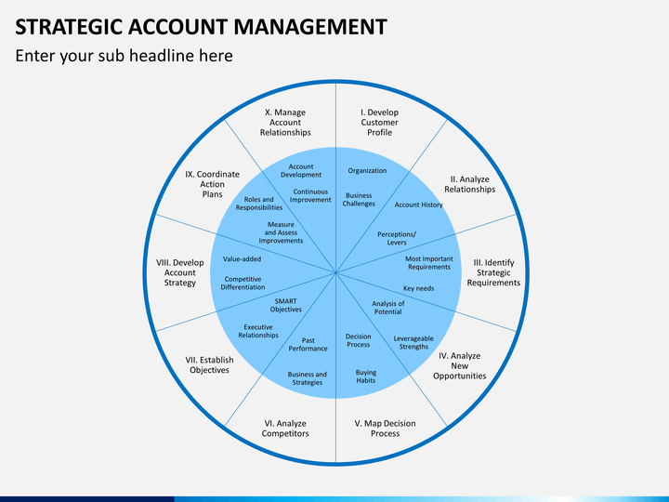

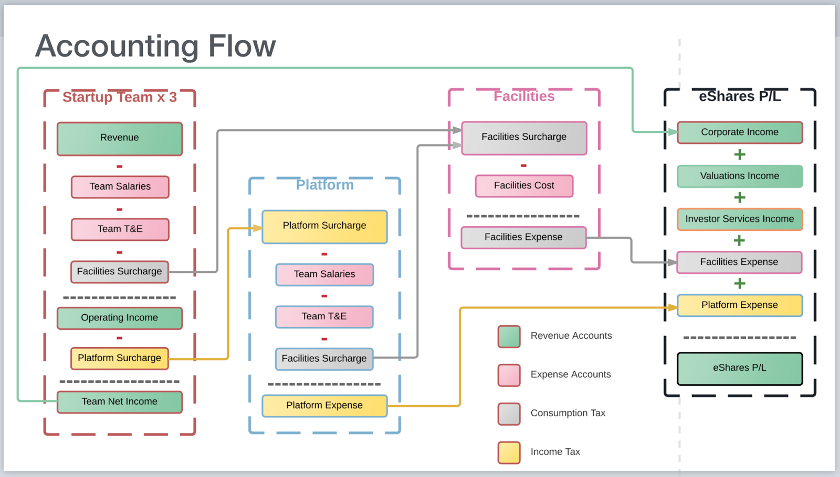

15

